**Delhi Assembly Election 2025 - Summary Report**

**Page 1: Voting Overview**

This page provides a high-level summary of the **Delhi Assembly Election 2025**, including the total seats won by major parties and a visual representation of the party-wise vote share.

**Key Highlights:**

* **Seats Won:**
  + **BJP:** 48
  + **AAP:** 22
* **Party-wise Vote Share:**
  + A **pie chart** illustrates the percentage of votes received by each party, offering a clear view of their electoral performance.

This page serves as a quick snapshot of the overall election results, helping viewers understand the distribution of seats and vote share among the contesting parties.

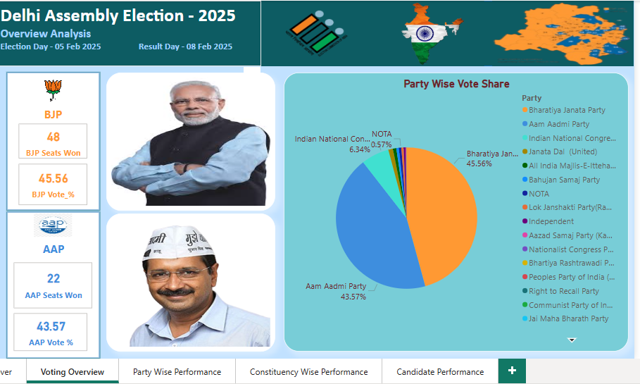

**Page 2: Party-Wise Performance**

This page presents an in-depth analysis of how different political parties performed in the **Delhi Assembly Election 2025**. It highlights the total votes secured by each party and their vote share percentage.

**Key Highlights:**

* **Total Votes by Party:** Displays the overall number of votes each party received.
* **Vote Share Percentage:** A pie chart representation showing the proportion of votes secured by each party.
* **Top Party by Vote Share:** Identifies the party that received the highest percentage of total votes.

**Interactive Feature:**

* **Select a Party:** Users can choose a specific party to see its detailed vote count and share.

This page helps in understanding the party-wise distribution of votes, making it easier to analyze their electoral performance.

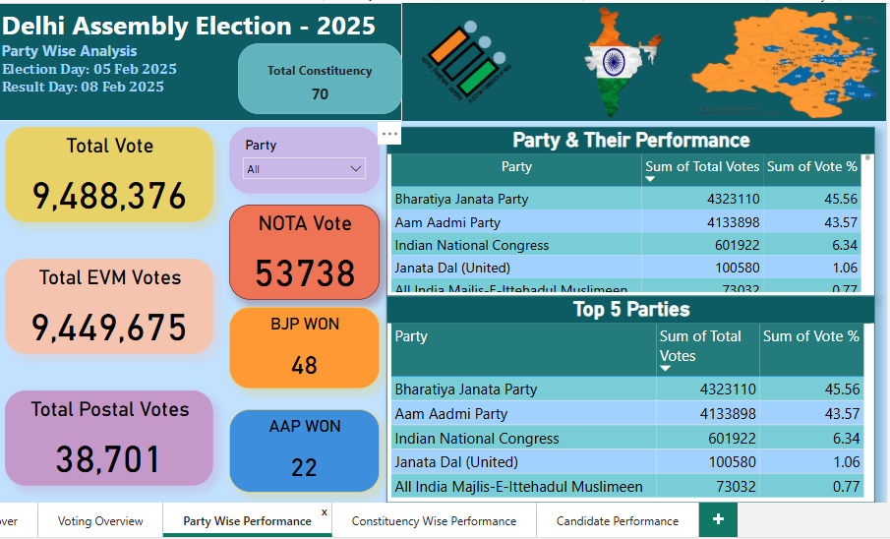

**Page 3 : Constituency-Wise Performance**

This page provides a detailed breakdown of election results at the **constituency level**, allowing for a deeper analysis of voter preferences across different regions.

**Key Highlights:**

* **Total Votes in the Constituency:** Displays the total number of votes cast in the selected constituency.
* **EVM & Postal Votes:** Shows a split between **EVM votes** and **postal votes**.
* **Winners & Runner-ups:**
  + **Winner:** Candidate with the highest votes.
  + **Runner-up:** Candidate with the second-highest votes.
  + **Second Runner-up:** Candidate with the third-highest votes.

**Interactive Feature:**

* **Select a Constituency:** Users can choose a specific constituency to view its detailed election results.

This page helps in analyzing the voting trends and competitiveness in each constituency.

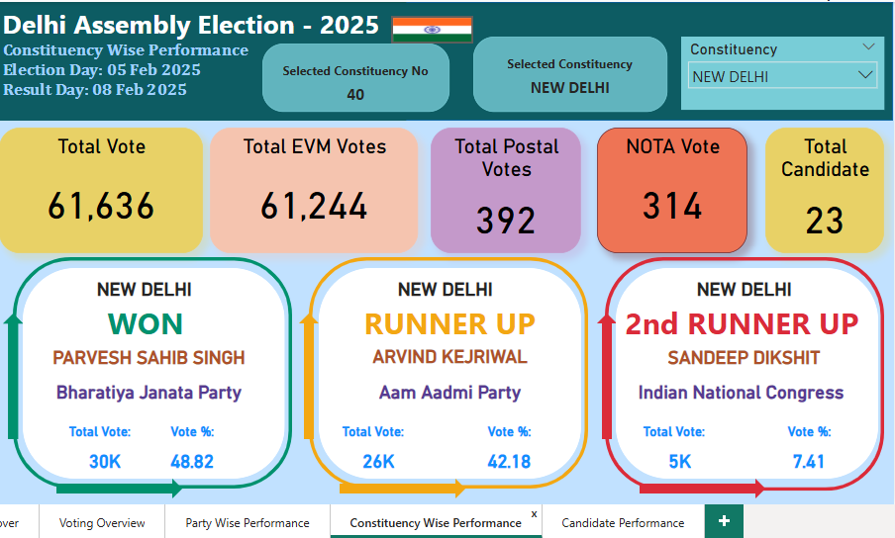

**Page 4: Candidate Performance**

This page provides a **detailed performance analysis of candidates** contesting in a selected constituency. It helps in understanding how each candidate fared in the elections.

**Key Highlights:**

* **Candidate List:** Displays all candidates who contested in the selected constituency.
* **Total Votes Received:** Shows the number of votes each candidate secured.
* **Vote Share Percentage:** Represents the candidate’s vote share as a percentage of total votes in the constituency.
* **Party Affiliation:** Indicates the party each candidate represents.

**Interactive Feature:**

* **Select a Constituency:** Users can choose a constituency to view the detailed performance of all candidates contesting in that region.

This page allows for a comparative analysis of candidates, helping to understand their popularity and electoral standing.

